ProbaPQuantum Computing Since Democritus by Scott Aaronson

Intro to Vectors & Complex Numbers

* **Scalar**
  + A quantity having only magnitude (no direction)
  + eg. distance, speed, time, mass
  + Written as



* **Vector**
  + A quantity with both a magnitude AND a direction
  + eg. displacement, velocity, acceleration, weight, quantum states
  + (velocity is a vector because it has a magnitude AND a direction whereas speed only has a magnitude)
  + Written as



* + 2D vector representation 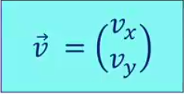

To find the vector component of two points - (vx2 - vx1 )

                                                                      (vy2 - vy1)

**Magnitude of vector :**

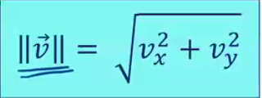

**Direction of a vector:**

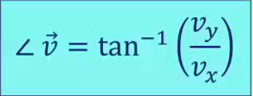

The arrow of that defines a vector determines the direction and the magnitude of the vector. The larger the arrow, the larger the magnitude.

**Vector addition** (commutative):

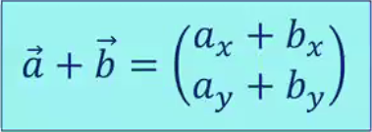

(only between vectors of the same dimension)

Ex:

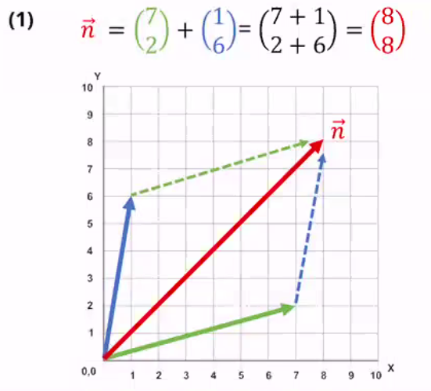

**Vector-scalar multiplication**:

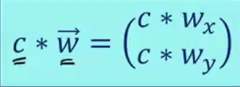

(preserves direction, changes length)

**Vector Decomposition:**

All Vectors can be broken into their respective x̂ (x hat) and ŷ (y hat) values

x̂ = 01     ŷ = 10

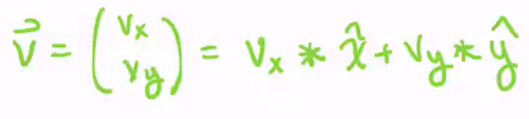

All vectors can be represented by the linear combination of  x̂ and ŷ.

scalars: a∈ℝ1  eg. 1, 4, 7, 91, 1024

2d vectors: v∈ℝ2  eg. 41, 138, 1643738

3d vectors: w∈ℝ3  eg. 01

            1

n-d vectors: q∈ℝn  eg. (q1)

            (q2)

            (...)

            (qn)

<https://math.typeit.org/>

**Complex numbers:**

**-1=i**

Complex numbers can have coefficient:

(bi)2 = b2i2 = -b2 (where b is a real number)

**-a=a*i** (where a is a real number)

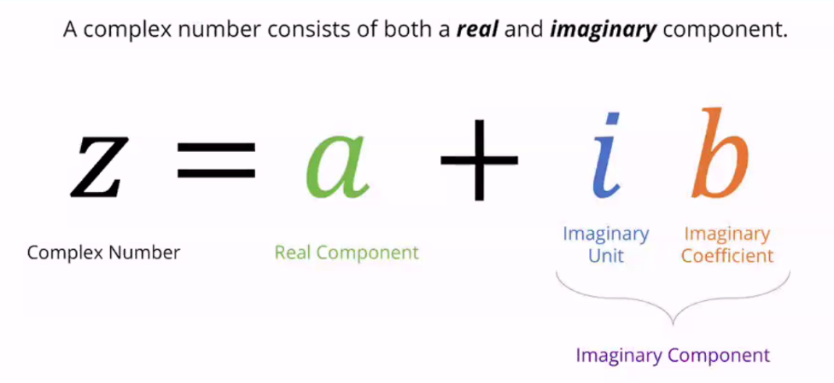

complex numbers can also be represented as vectors in the 2D complex plane

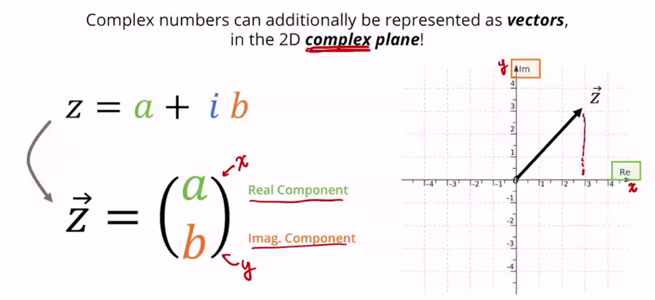

Complex number addition:

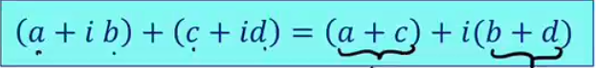

Complex number multiplication:

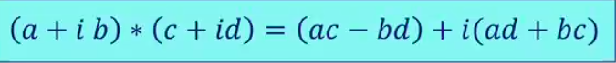

Complex Conjugation:

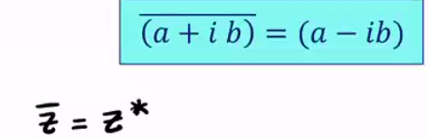

eg. if z = 3+4i, its complex conjugate is 3-4i

Complex Modulus:

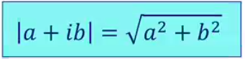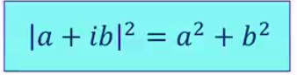

|z|2 = z *  z

Euler’s identity:

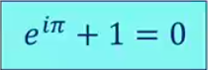

Complex exponential addition

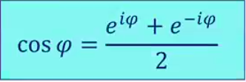

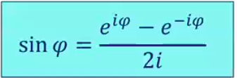

Complex exponential multiplication:

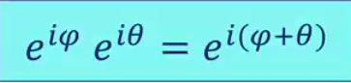

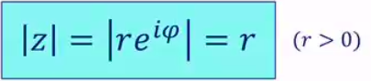

Complex exponential conjugation:



**GUYS JUST WATCH THE LECTURE AGAIN IF U DONT UNDERSTAND THIS STUFF… PLS DONT FIRE AT US...**

**^^^^^^^^^^^^^^^^^^^^^^^^^^^^^^^^^^^^^^^^^^^^^^^^^^^^^^^^^^^^^^^^^^^^^^^^**

